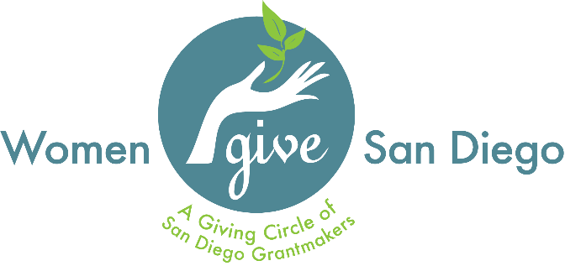

Purpose
The Women Give San Diego Fellowship Program is an outreach initiative to encourage diversity and inclusion within the organization’s membership by offering incentives to prospective members who are part of diverse communities. These include, but are not limited to ethnically or racially diverse, economically diverse, LGBTQIA individuals, veterans and military spouses, or age-defined communities. For others who may be unable to afford membership at this time, we hope that the Fellowship Program will make it possible for them to participate. In summation, Women Give San Diego has launched this program to seek to understand systemic barriers to entry that some may face when considering membership.

Women Give San Diego’s ultimate goal is to build a membership that is inclusive of and representative of our community because we know that this will create a stronger organization, more informed grantmaking, and a fostering of connections among amazing San Diego women who might not otherwise meet. We believe the result of a membership that is more reflective of the communities that we serve is that WGSD ultimately will have greater impact on the economic self-sufficiency of women and girls in San Diego County.

Benefits and Expectations of Participation
Women Give San Diego provides the following benefits for one year:
- Membership underwritten for one year (may be renewed for up to one additional year; 2 years total)
- Membership to San Diego Grantmakers and related resources
- Invitations to community events (based on availability)
- Access to leadership development opportunities (when applicable)
- Networking opportunities with business and community leaders

Regular attendance at WGSD membership meetings and events is encouraged.

Eligibility Criteria
Eligible applicants must:
- Be a part of a diverse community; a community underrepresented in philanthropy;
- Not be a current member of WGSD;
- If able, continue paid membership in WGSD at the conclusion of the fellowship period;
- Attend membership meetings, programs, and events;
- Join one of WGSD’s leadership teams

For more information, visit www.womengivesd.org or email fellowships@womengivesd.org.

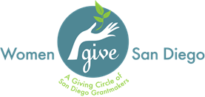

Women Give San Diego
Fellowship Program Application

Please complete this application to be considered for the Women Give San Diego Fellowship Program. Submit your completed application to fellowships@womengivesd.org. Fellowship applications are reviewed on a rolling basis. Applicants who are granted a Fellowship will be notified via email. If you have any questions or need assistance, please email fellowships@womengivesd.org.

Date: ________________________________________________
Name: ____________________________________________________________________________________________
Email: ___________________________________________ Preferred Phone Number: ____________________________
Preferred Mailing Address: ____________________________________________________________________________________________________________________________________________________________________________________________________

How did you hear about WGSD?
__________________________________________________________________________________________________
__________________________________________________________________________________________________
If a WGSD member recommended you, please list their name: _______________________________________________

What are your philanthropic priorities? What are causes are most important to you?
__________________________________________________________________________________________________
__________________________________________________________________________________________________

Check all that apply to you:
___ Community Organizer ___ Activist ___ Entrepreneur ___Small Business Owner ___ Volunteer
___ Philanthropist ___Corporate Executive ___ Recent College Graduate ___ Politician ___________________
Other

Professional:
Job Title: _____________________________________________
Company: ____________________________________________

Why do you want to become a member of WGSD?
____________________________________________________________________________________________________________________________________________________________________________________________________________________________________________________________________________________________________________________________________________________________________________________________________________________________________________________________________________________________________________________________________________________________________________________________________________
What are your barriers to entry? (Why might you not join WGSD without the Fellowship Program?)
____________________________________________________________________________________________________________________________________________________________________________________________________

How will you bring a diverse perspective to Women Give San Diego?
____________________________________________________________________________________________________________________________________________________________________________________________________

Fellowship recipients are encouraged to be active members of WGSD and participate in the following:
- Serve on a leadership team
- Attend membership meetings, programs, and events
- Network with fellow members and community partners
- Serve as a spokesperson to support WGSD outreach efforts

Which of the activities above is most appealing to you and why? _____________________________________________
________________________________________________________________________________________________________________________________________________________________________________________________________________________________________________________________________________________________________________________________________________________________________________________________________
If you would like (completely optional), please feel free to attach a photo to this application).

** To be completed by Women Give San Diego **
Date received: ______________________
Was applicant nominated by a current member of WGSD member: Y/N
Does applicant meet eligibility criteria: Y/N
Note: _____________________________________________________________________________________________
__________________________________________________________________________________________________
Fellowship Awarded: Y/N
Applicant Notified (Date): _________________________________________

